How to setup schedule, away mode and timer of Tenda Smart Plug in Beli APP?

Beli APP is designed to control Tenda Smart Plug locally and also remotely. With Beli app, we can easily control and monitor Tenda Smart Plug wherever we are and make our home smart.

Step1: On the Beli app, go to Devices page, click on SP3, then tap Schedule icon.

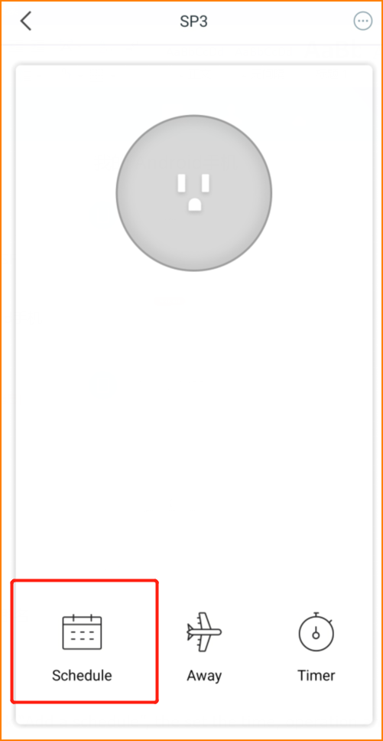

Step2: Click “Add a schedule”, the set the time, operation and repeat. Take the picture below for example, the SP3 will turn on at 18:00 o’clock everyday. Do remember click “Save”.

